GYROSCOPE
Gyro: Circular Motion  Cross Product: $\vec{a }×\vec{b }=\left|\vec{a }\right|∙\left|\vec{b }\right|\sin{θ}\hat{η}$ |  | $$\hat{i}$$
 | $$\hat{K}$$ | $$CW: +ve$$ | $$CCW: -ve$$ | $$\hat{j}$$
Linear Momentum: $\vec{P }=m\vec{V }$ | Angular Momentum: $\vec{L }=\vec{r }×\vec{P }=I \vec{ω }$

Newtons 2nd Law of Motion:  $$\vec{τ }=\frac{d\vec{L }}{dt}=\frac{d\left(\vec{r }×\vec{P }\right)}{dt}=\frac{d\left(I\vec{ω }\right)}{dt}=\frac{d\left(Iω \hat{ω}\right)}{dt}$$ |  | Magnitude: $\left|\vec{L }\right|=Iω$ |  | Direction: $\hat{L}=\hat{ω}$
 |  | $$Precision Velocity: \frac{d\hat{ω}}{dt}=\vec{ω_{P}}$$
CASE-I: Let the direction of angular velocity remains same w. r. t. time. only it’s magnitude is changing.  $$\vec{τ }=\frac{d\left(Iω \hat{ω}\right)}{dt}=I \vec{α } \hat{α}$$ |  | CASE-II: Let the magnitude of angular velocity remains same w. r. t. time. only it’s direction is changing.  $$\vec{τ }=\frac{d\left(Iω \hat{ω}\right)}{dt}=Iω\frac{d\hat{ω}}{dt}=I\left[\vec{ω_{P}}×\vec{ω }\right]=\begin{matrix}Gyroscopic \\ Active Torque\end{matrix}$$
Acceleration: $\hat{α}=\hat{ω}$ | Retardation: $\hat{α}=-\hat{ω}$ | $$Reactive Gyroscopic Torque: \vec{T }=I\left[\vec{ω }×\vec{ω_{P}}\right]$$
 |  | Magnitude: $T=I ω ω_{P}$ | Direction: $\hat{T }=\hat{ω }×\hat{ω_{P}}$

Newtons 3rd Law of Motion: Every action has equal and opposite reaction.
Hence, for all Active gyroscopic, Reactive gyroscopic Will be present in the system.
GYROSCOPIC PHENOMENON:
Spin $\left(\vec{ω }\right):$ Direction of Angular Momentum  Precession ($\vec{ω_{P}}$): Direction about which direction of angular momentum changes.  Reactive Gyroscopic Torque:$\vec{T }=I\left[\vec{ω }×\vec{ω_{P}}\right]$ |  | Axis | Planes
 | $$\vec{ω }$$
 | $$\vec{ω_{P}}$$
 | $$\vec{ω }×\vec{ω_{P}}$$
DIAGRAM METHOD: It’s almost same as table method with Torque diagram. This diagram will give the active gyroscopic torque direction. Reactive Gyroscopic torque will be opposite to Active Gyroscopic torque.
AEROPLANES | NAVAL SHIP
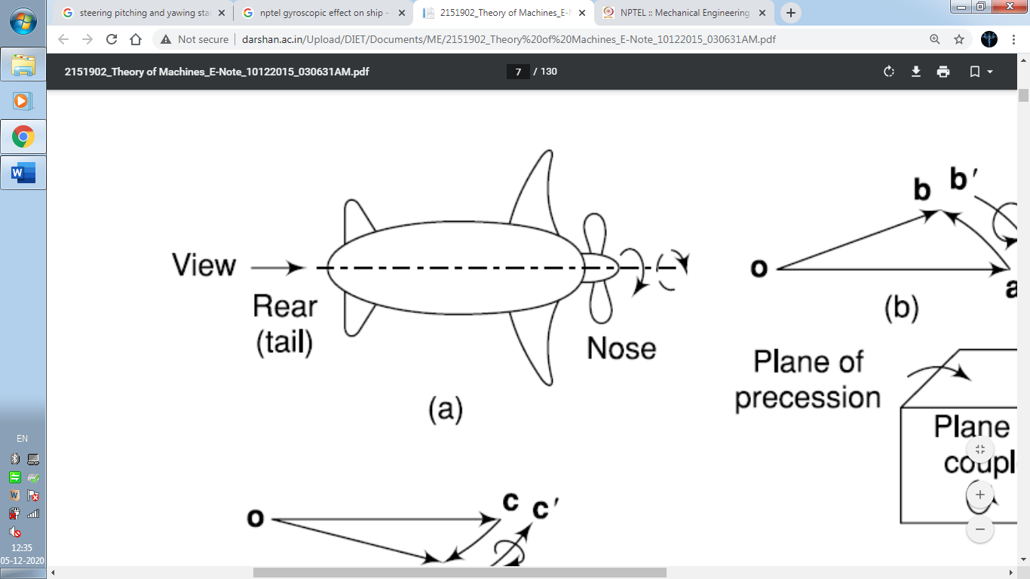 | 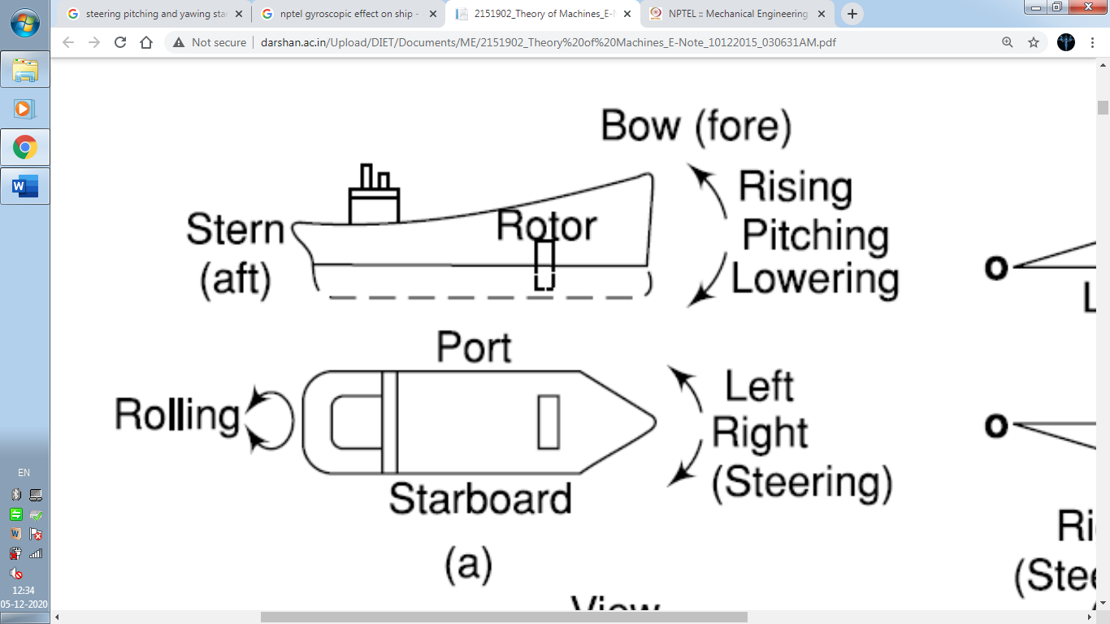
FOR NAVAL SHIP:
- Steering: Turning of the ship either towards starboard side or port side in known as steering.
- Pitching: Oscillation of the ship about horizontal transverse axis is known as pitching. Bow will rise or fall.
- Rolling: Oscillation of the ship about longitudinal axis.
NOTE:
- Sometime Pitching is given in SHM.
$$x=x_{0}\sin{ωt}$$ | $$ω={2π}/{Time Period}$$
- There will be no gyroscopic effect due to Rolling.

